**Structuring Rest Api**

• Initialize a new Node.js project with npm init.

• Install Express using npm install express.

• Create a server that listens on a specified port (e.g., 3000).

• Implement a simple GET endpoint (/api) that returns a JSON response (e.g., { message: "Welcome to the API!" }).

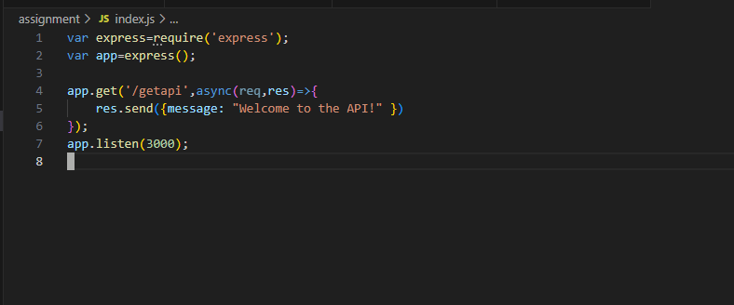

**Output:**

